**North Harford High School Hawks Boosters**

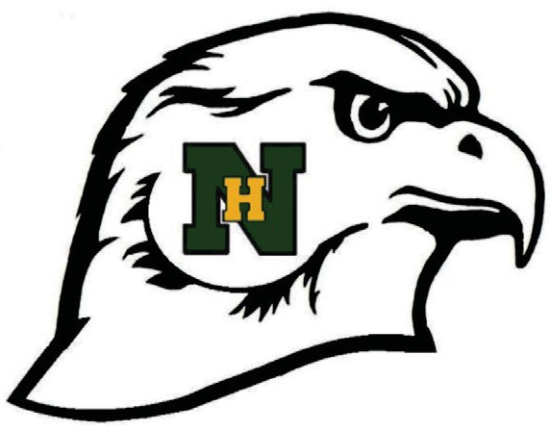

**MEMBERSHIP APPLICATION 2025-2026**

School budgets provide limited funds for extracurricular activities. North Harford High School Hawks Boosters fills in to provide our athletes with quality equipment and support so students can reach their potential in the competitive world of sports.

With so many wonderful athletes … ***we need the support of each family.***

**Visit our website at** [**http://clubs.bluesombrero.com/nharfordhsboosters**](http://clubs.bluesombrero.com/nharfordhsboosters) **to join.**

**Check Your Membership Level Below** (Membership benefits are for the current school year)

**HAWKS GOLD HAWKS WHITE HAWKS GREEN HAWKS**

**MEMBERSHIP $100 MEMBERSHIP $75 MEMBERSHIP $50 MEMBERSHIP $25**

|  |  |  |  |
| --- | --- | --- | --- |
| * Hawks Umbrella * Hawks Blanket * Scholarship   Qualification   * Hawks Activities   Updates and Award  Notifications by Email | * Hawks Blanket * Scholarship   Qualification   * Hawks Activities   Updates and Award  Notifications by Email | * Hawks Umbrella * Scholarship   Qualification   * Hawks Activities   Updates and Award  Notifications by Email | * Scholarship   Qualification   * Hawks Activities   Updates and Award  Notifications by Email |

PARENT NAME(S)

ADDRESS

HOME PHONE NUMBER CELL PHONE NUMBER(S)

EMAIL ADDRESS(ES)

*ALL INFORMATION IS CONFIDENTIAL. EMAILS ARE REQUESTED AS MOST COMMUNICATION FROM THE HAWKS BOOSTERS WILL BE DONE VIA EMAIL.*

**STUDENT NAME SPORT(S) GRADE**

**I would like to help out with…**

Banners/Bricks Homecoming Bull & Shrimp Roast Concessions Scholarship Membership

If you cannot enroll through the website, please return this form with a check payable to **North Harford Hawks Booster Club**

Mail to **North Harford Boosters Membership – North Harford High School 211 Pylesville Road, Pylesville, MD 21132**

You will be contacted to arrange your merchandise pickup/delivery date. **Thank you for your support!**

**BOOSTER USE ONLY:**

**Amount: $_________ Cash Credit Check# __________ Incentive Gift Fulfilled Date: ____________________**